Food Labeling

Background

HHS’ Food and Drug Administration has been give the authority and responsibility to oversee labeling on packaged foods. USDA’s Food Safety and Inspection Service regulates the labeling of meat and poultry under separate statutory authority, but has labeling policies that are consistent with FDA’s.

As a part of its authority in labeling, FDA oversees food labeling in the following key areas:

- Ingredients- A packaged food must list ingredients in order of predominance (e.g., “wheat flour, sugar, salt, butter”)

- Nutrition Facts- Most packaged food must have a listing of nutrients and related information on the Information Panel that is usually on the side or rear of the package (e.g., serving size, calories, fat, carbohydrates, sodium, protein). This label has proven to be a source of information that consumer like and trust. However, busy shoppers can’t always take the time to read it, and some low literacy consumers do not understand it.

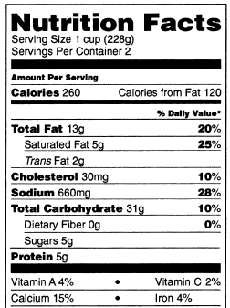

- Nutrient Content Claims- Many food packages have claims such as “low fat,” “high fiber,” “reduced calories,” and “cholesterol free.” FDA has defined such terms so that they are consistent.

- Health Claims- FDA has approved 12 specific “health claims” that a food can make, such as “Diets low in sodium may reduce the risk of high blood pressure, a disease associated with many factors.”

- Raw Fruits, Vegetables, and Fish- Many supermarkets post placards listing nutrition information for raw produce and fish, and FDA has provided easily downloadable posters for such information (e.g., a medium sized peach contains X amount of fat, calories, etc.). [FDA provides this information for point-of-purchase labeling for the 20 most commonly consumed fruits and vegetables as well as the 20 most commonly consumed varieties of fish]

- Allergy information- Since 2006, the major food allergens are required to be specifically noted on the Information Panel of the food label (i.e., fish, milk, soybeans, wheat, eggs, shellfish, tree nuts, and peanuts)

- Restaurant Menus – If a restaurant menu makes a claim (e.g., “low fat), it must provide nutrition information to the patron. Otherwise restaurant menus are exempt from nutrition labeling rules. However, some cities and states have begun requiring menu labeling, and the restaurant industry is supporting Federal legislation (to assure one national menu labeling requirement).

Front-Of-Package Nutrition Labeling

With the increased public interest in identifying healthier foods, U.S. food processors have been adding nutritional information to the front of packages in addition to nutrient content or health claims, and this type of labeling is seen in other countries as well. Examples include:

- Symbols that broadly suggest that a food is “healthy,” “good for you,” or “a better choice.” For example, many food processors have supported one such symbol, known as Smart Choices. However, some nutritionists and public health advocates have concluded that the program’s criteria for inclusion may be too lenient

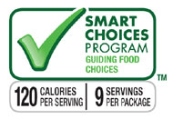

- Symbols that purport to list on the front of the packages the key nutrients in that food. These often use the color green, which may suggest positive attributes. However, the nutrients selected for inclusion vary and may not present a full picture of the nutrient profile of a product.

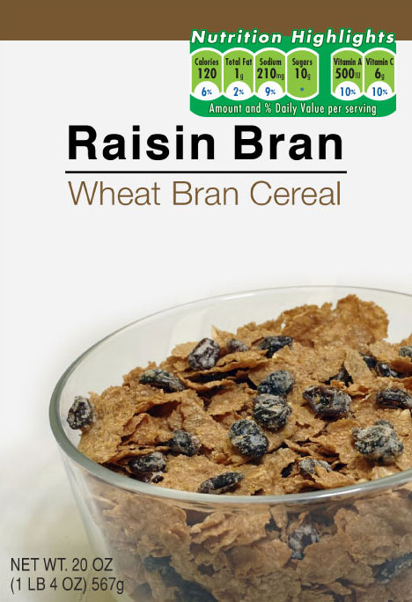

- Shelf-label symbols employed by supermarkets that give foods a “grade,” such as Guiding Stars (the more stars, the “healthier” the food, under the Guiding Stars criteria); or Nuval, in many supermarkets, which gives a numerical score based on several factors associated with the food (1 – 100, with 100 being best).




- Symbols that provide both specific nutrition information and gradations about positive or negative levels of nutrients. An example of this is the British “traffic light” system, which is voluntary in that country. [Note: Britain does not have mandatory nutrition labeling or a mandatory format for nutrition labeling; however, if a claim is made then nutrition labeling is required.]

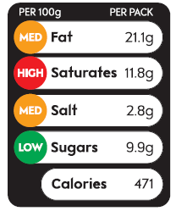

- Federal dietary guidance symbols, that are intended to provide advice on how to construct a healthy diet, have also been used on packages to provide nutrition information. However, the presence of logos such as My Pyramid are not determined by a specific nutrient profile of the food. Questions have been raised about whether the presence of such a logo may imply that a food has healthy attributes, even if the total fat, saturated fat content, cholesterol, and/or sodium content are high (e.g. the logo has been used on products that provide 80% of the Daily Value for saturated fat and 54% of the Daily Value for sodium).

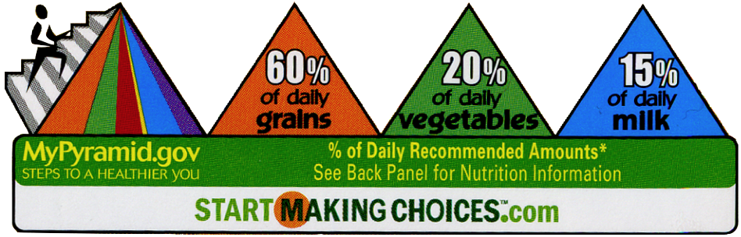

FAQs

Q: How do consumers view and use Front of Pack labels?

A: The existing consumer research suggests that consumers like FOP labeling, finding it to be a time-saver. Consumers do not fully trust it, however, and find the plethora of FOP labels confusing. Most importantly, research suggests that FOP labels can give consumers an overrated view of a food’s healthiness, and make it less likely that consumers will read the complete Nutrition Facts information on the back.

Q: Are some FOP labels better than others?

A: We don’t fully know. The manufacturer labels are clearly intended to encourage the consumer to buy their product. The grocery stores’ incentive is to help consumers choose among like products, not buy a particular product, and their systems are more likely to focus on encouraging consumers to shop in their store. FDA intends to conduct further research in the coming months that will compare several FOP types, with the goal of determining which best help consumers make informed choices.

Q: Where do nutrition experts stand on FOP?

A: They are divided. For example, some supported the Smart Choices program and its criteria, others did not. The nutrition community will be able to weigh in more formally through an Institute of Medicine study of FOP labeling directed by the 2009 Labor/HHS appropriations bill.

Q: Does FDA have the authority to regulate the criteria under which a FOP program decides who gets the symbol?

A: Yes, the Food, Drug, and Cosmetic Act directs FDA to prohibit false or misleading statements on food labels, and the Nutrition Labeling and Education Act gave FDA authority related to nutrition labeling, including the use of related symbols. FDA is developing a proposed regulation that would define the nutritional criteria that would have to be met by manufacturers making broad FOP or shelf label claims concerning the nutritional quality of a food, whether the claim is made in text or in symbols. FDA’s intent is to provide standardized, science-based criteria on which FOP nutrition labeling must be based.

Q: The U.K. developed a traffic light system that provides the actual nutrient levels plus the “grade” provided by the red, amber and green lights. Is there research guiding us on whether it is a good symbol?

A: Yes, there is British quantitative research in which the authors state that “overall the balance of evidence from the research shows that the strongest FOP labels are those which combine text (high, medium, low), traffic light colours, and %GDA information.” The qualitative part of the study suggested that actual use of FOP symbols is relatively low and use of symbols is related to consumers’ nutrition motivation; and that the presence of several different symbols causes difficulties for consumers. FDA intends to test a version of this type of system with American consumers as part of its planned research agenda.

Q: If FDA’s consumer research concludes that one type of symbol is best, can the government mandate a single such symbol?

A: The nutrition labeling statute gives FDA authority to ensure that consumers get nutrition information and that it be provided in an effective way. The agency focused initially on the Nutrition Facts label, which has proven to be successful. Now, however, with manufacturers desiring to use the front of the package for nutrition information, the logical next step may be to ensure that such labeling is done in the best way possible. That could mean setting criteria governing how voluntary FOP systems are done or establishing a single, uniform, government-mandated symbol. The agency is drafting a regulation that would set specific criteria for the use of dietary guidance claims, including symbols, and would have the effect of providing standardized criteria for all food manufacturers.

Q: With whom is FDA working to develop its research plans?

A: First, the agency is working closely with USDA officials, as it will be important that USDA’s oversight of labeling of meat and poultry be consistent with FDA decisions on the rest of the food supply. The agency is also assisting the IOM in the development of its study, in consultation also with USDA and the Centers for Disease Control and Prevention. And FDA and USDA will be working with retailers, private design experts, food manufacturers, nutrition experts, and British health officials, to ensure that a comprehensive research agenda is conceived and carried out.

Q: Does this announcement affect nutrition information on restaurant menus, which some states and cities are beginning to require?

A: No, FDA does not now have the authority to require that nutrition information be provided for restaurant foods. However, there is legislation before Congress that would do so, and has the support of both consumer groups and the National Restaurant Association.

Q: Will FDA’s requirements cover all packaged foods?

A: The Department of Agriculture shares food labeling responsibility with FDA, as USDA regulates meat and poultry. FDA and USDA officials have been in close coordination on these issues, and intend to work together to reach a common goal that will best assist consumers in making healthy dietary choices.

Q: What is the public health need here?

A: Americans are growing increasingly overweight and obese, with two out of every three adults, and a growing percentage of children, in those categories, resulting in dramatic increases in the prevalence of diseases such as diabetes and hypertension. The concomitant annual death toll among our citizens is estimated to be 300,000, and the associated costs in health care alone amount to $147 billion.

Q: Does FDA expect that improvements in FOP labeling will lower rates of overweight and obesity?

A: Scientists cannot predict with certainty how better information will affect behavior, that is, whether consumers will actually choose healthier foods. But they do believe that good, useful information will enable consumers to make informed choices, and be able to differentiate among foods of differing nutritional qualities.

Q: Why retailers? Don’t food manufacturers apply the labeling on foods?

A: Retailers are very interested in labeling of this nature. Several major grocery chains have adopted shelf labeling systems that are similar to FOP labeling. The intent of those systems is not to persuade a consumer to buy a particular product, but to show their customers that they will have information allowing consumers to choose among similar products (e.g, which version of raisin bran has fewer calories). FDA believes retailers may become a major driver in the movement toward improved FOP labeling.

Q: In the meantime, how can consumers make choices with all the different types of labeling schemes in the market?

A: Consumers can currently use the Nutrition Facts label to make judgments for themselves about the food products. The % Daily Value is a useful tool for comparing various products whether looking at nutrients to limit such as sodium or saturated fat or nutrients to get enough of such as fiber or vitamins and minerals. Keep in mind that 5% of the Daily Value (DV) is low and 20% of the DV is high. The Nutrition Facts label provides information based on a single serving of the product and the serving size is indicated in Nutrition Facts.

