Model Tweets:

- Reminder: It’s normal to feel hungry a few hours after eating, regardless of how many calories consumed. #SchoolFoodsRule

- Athletes who have additional calorie needs can purchase a la carte items to supplement their school lunch. #SchoolFoodsRule

- Protein requirement for school lunch has always been 1-2 ozs. This year kids are getting more fruits/veggies to go with it! #SchoolFoodsRule

- New school meals create “opportunity 4 schools 2 incorporate nutrient-rich lean meat options” says @BeefUSA #SchoolFoodsRule bit.ly/VItxew

- Even meat industry seems to agree there’s enough protein under the new school lunch guidelines--@BeefUSA #SchoolFoodsRule bit.ly/VItxew

- Adjusting to change takes time. But federally-funded lunches are nutrition programs and need to serve nutritious food. #SchoolFoodsRule

- The new school meal stds are designed to provide students w/ the nutrition they need to be successful in school #SchoolFoodsRule

- Just b/c kids are served huge portions at restaurants doesn’t mean we should serve them huge portions for school lunch. #SchoolFoodsRule

- The new 850 calorie maximum in school lunches should be plenty for most high school students. #SchoolFoodsRule

- 23 million kids are obese. Healthy school meals help address this. #SchoolFoodsRule

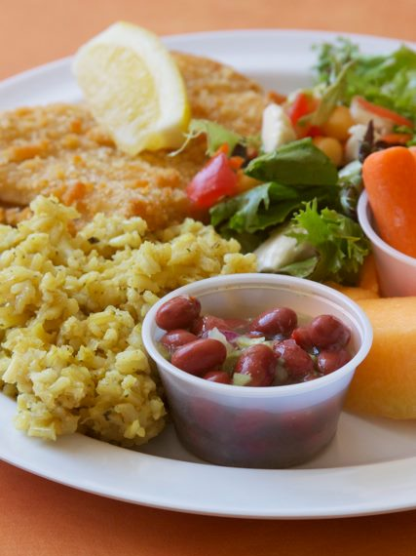

Model Facebook Posts:

The new calorie limits for school lunches are based on recommendations from the Institute of Medicine. It may not seem like enough food at first (especially given the huge portions kids are used to being served at restaurants!), but it should be enough to meet children’s energy needs. Click share if this lunch from Provo School District (Utah) looks good to you!
https://www.facebook.com/photo.php?fbid=363191980422197&set=a.115991501808914.20938.115793121828752&type=1&theater

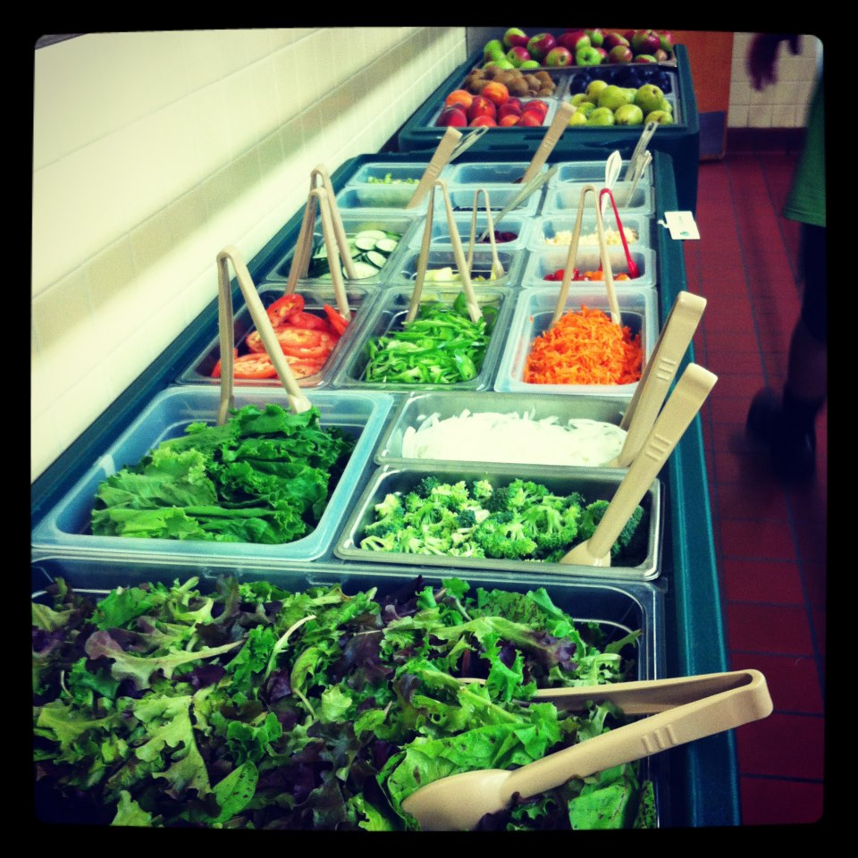
Obesity is currently costing the American economy $190 billion per year. Federally funded school meals should not contribute to those costs. Salad bars are a great way to encourage kids to eat more fruits and veggies in schools. Share this beautiful salad bar from Burlington (VT) Schools.

http://www.facebook.com/photo.php?fbid=482075065136206&set=a.224531074223941.65793.224186890925026&type=1&theater

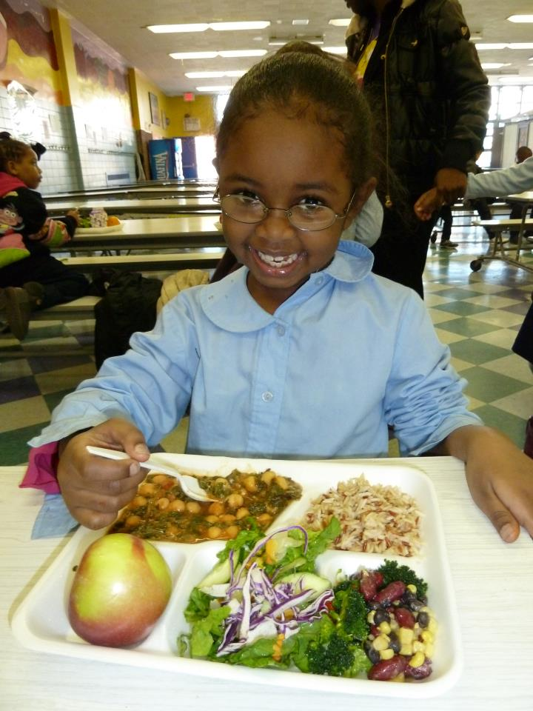

Schools across the country have been serving healthy meals, and most students are enjoying them and leaving the lunchroom satisfied. Some students may be resistant at first to the new foods being served at their schools, but that doesn’t mean they won’t enjoy the food in the future.

http://www.facebook.com/photo.php?fbid=273840532651137&set=pb.140034452698413.-2207520000.1348176339&type=1&theater

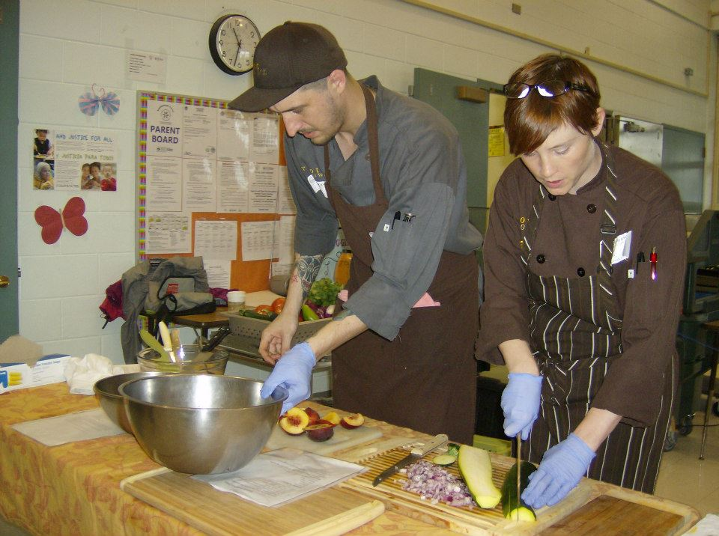
Schools are building support for the new lunches by hosting taste tests and recipe contests, voting for favorites, giving menu items snazzy names, and engaging student “food ambassadors” to help generate additional support. School chefs in Denver Public Schools in Colorado have used cooking demonstrations. Homemade salsa, anyone!?

https://www.facebook.com/photo.php?fbid=521342304558934&set=a.521340691225762.137761.294158123944021&type=1&theater

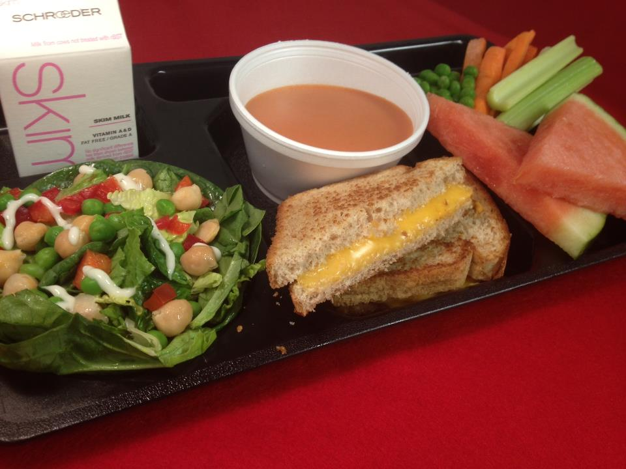
Schools are a great place to teach children healthy habits, which foods are nutritious and reasonable portion control. Share if you think this lunch from Saint Paul Public Schools looks tasty!

http://www.facebook.com/photo.php?fbid=407397385980387&set=a.139999112720217.38295.130306273689501&type=1&theater

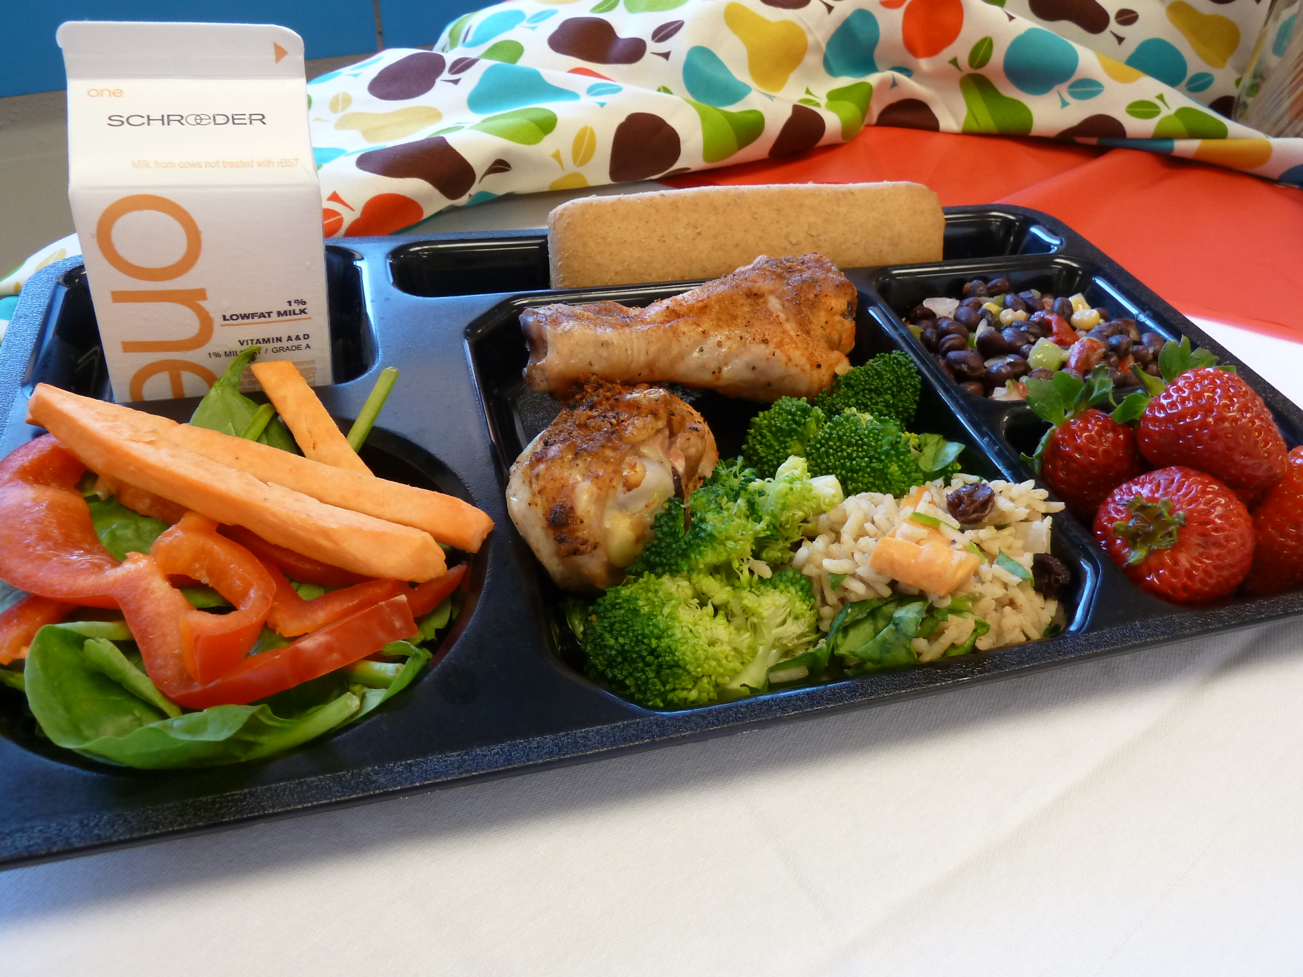

American school-aged children consume 50-240% more protein (depending on age) than they need. The new school lunch standards are in line with actual nutritional needs, rather than current over-consumption. This beautiful lunch from Saint Paul Public Schools is a great example of a delicious, balanced meal!



Ok, we get it. Some student athletes may need more food than the average student to get them through the day. But, not all students are linebackers and we shouldn’t feed them like they are. SHARE if you agree!

