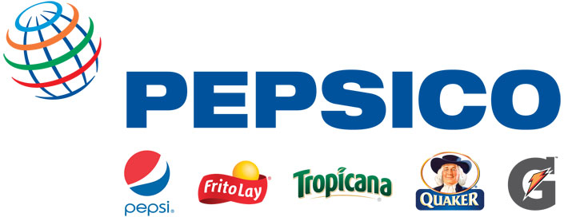
Purchase, New York Telephone: 914-253-2000 www.pepsico.com

Media Contacts: Dave DeCecco Michelle Naughton
914-253-2655 646-285-8224
david.dececco@pepsi.com michelle.naughton@pepsi.com

PEPSICO SETS INDUSTRY STANDARD BY ESTABLISHING THE FIRST
CONSISTENT GLOBAL APPROACH TO SELLING BEVERAGES IN SCHOOLS

PURCHASE, N.Y. – March 16, 2010 – PepsiCo (NYSE: PEP) announced today it is voluntarily adopting a new global policy to stop sales of full-sugar soft drinks to primary and secondary schools by 2012. The industry-leading policy establishes for the first time a consistent global approach to the sale of beverages to schools by a major beverage company.

The policy applies in all countries outside the United States, and is generally consistent with the company’s existing U.S. policy, which remains unchanged.

PepsiCo Chairman and CEO Indra Nooyi said: “We have long advocated for school settings to be made as conducive as possible to promoting the health of students, and we have programs under way with school authorities in several countries to do that. This includes restoring or expanding physical education and promoting nutrition education. This global policy will serve as an important part of that mission, by expanding our offerings of low-calorie and nutritious beverages.”

Details of the PepsiCo policy were drawn up following discussions with the World Heart Federation in Geneva. The World Heart Federation is the premier nongovernmental organization recognized by the World Health Organization as its leading partner in the prevention and control of cardiovascular disease.

“The World Heart Federation welcomes PepsiCo’s announcement that it will launch a new policy on stopping the sale of sugary beverages to schools globally,” commented Pekka Puska, President of the World Heart Federation. “The soft drinks industry has voluntarily removed full-calorie carbonated beverages from schools in certain countries. The World Heart Federation has been leading discussions with industry for such a policy at a global level and is pleased that PepsiCo is leading the way within the beverage industry.”

PepsiCo will work with its bottlers, vending companies and third-party distributors -- in collaboration with parents, community leaders and schools officials around the world -- to offer low-calorie beverages for primary and secondary schools.

The global school beverage policy continues to advance PepsiCo’s commitment to reducing calories in schools by offering students a wider range of low-calorie and nutritious beverages in appropriate portions.

PepsiCo worked with the Alliance for a Healthier Generation -- a joint initiative of the American Heart Association and the William J. Clinton Foundation and other beverage industry leaders -- to change the mix of beverages in U.S. schools through voluntary guidelines. The guidelines precluded the sale of full-sugar soft drinks to students in elementary and secondary schools, permitting only low-calorie drinks and portion-controlled juices, sports drinks and waters. In early March, three years after guidelines were announced, it was reported that 98.8% of measured schools were in compliance.

About PepsiCo
PepsiCo offers the world's largest portfolio of billion-dollar food and beverage brands, including 19 different product lines that each generates more than $1 billion in annual retail sales. Our main businesses - Frito-Lay, Quaker, Pepsi-Cola, Tropicana and Gatorade - also make hundreds of other nourishing, tasty foods and drinks that bring joy to our consumers in more than 200 countries. With annualized revenues of nearly $60 billion, PepsiCo's people are united by our unique commitment to sustainable growth, called Performance with Purpose. By dedicating ourselves to offering a broad array of choices for healthy, convenient and fun nourishment, reducing our environmental impact, and fostering a diverse and inclusive workplace culture, PepsiCo balances strong financial returns with giving back to our communities worldwide. In recognition of its continued sustainability efforts, PepsiCo was named for the third time to the Dow Jones Sustainability World Index (DJSI World) and for the fourth time to the Dow Jones Sustainability North America Index (DJSI North America) in 2009. For more information, please visit www.pepsico.com.

# # #

