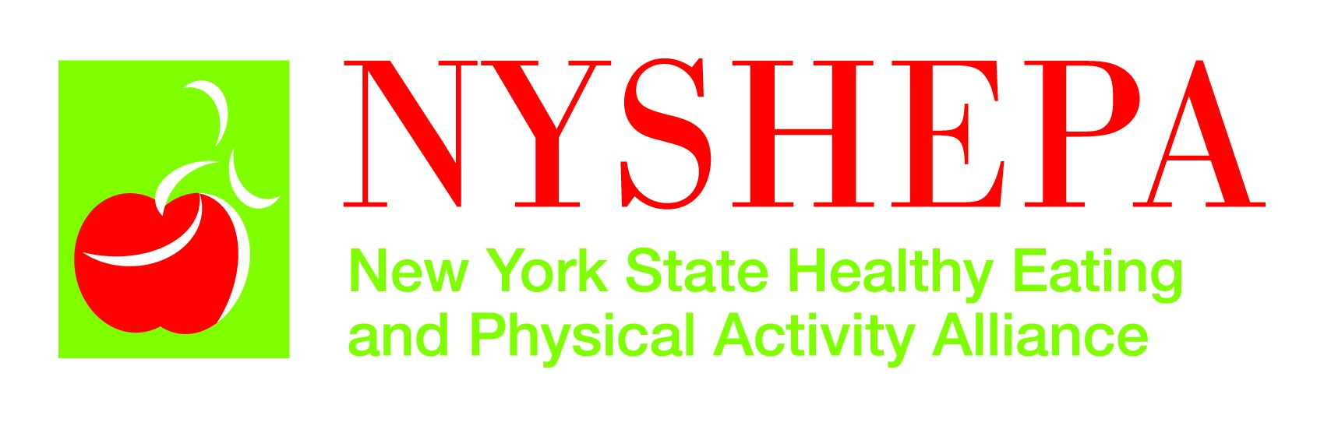

NEW YORK STATE SUGAR SWEETENED BEVERAGE TAX CAMPAIGN 2010

Campaign Goal:

Enact a penny-per-ounce tax on sugar sweetened beverages in New York State

Objectives:

- (Grass tops) Increase support for a sugar sweetened beverage tax in the NYS legislature

- (Grassroots) Increase grassroots action calling for an increase in the tax on sugar sweetened beverages.

- (Media) Increase public support for the SSB tax by disseminating key positive messages and if necessary countering negative messages

Objective 1 (Grass Tops Action)

Increase support for a sugar sweetened beverage tax in the NYS legislature

Activities:

- Identify key legislators to target (NYAM List) – Done

- Finalize messages and talking points – Done

- Identify who might have the most influence over key decision makers – Unions, AARP?

- Identify influential legislators in each house who is willing to champion the tax - Klein?

- Identify organizations that are willing to call or meet with targeted legislators about the tax/ Schedule and track which groups are meeting with whom (NYAM – send all meeting info and results to Ana)

- Initiate a letter writing/fax/phone call campaign to targeted legislators using key messages - ??

- Generate email messages to legislators requesting support– CSPI, also NYSPHA and PHANYC should have a an online advocacy tool working by March.

- Compile op eds, editorials and LTE’s and send out or bring to legislators

- Hold a symposium near the LOB to raise the profile of the issue, increase positive messages, and educate legislators. Invite prominent speakers like Kelly Brownell, Daines, David Ludwig NYAM-NYSHEPA – 3/8

- Legislative Action Day – NYAM-NYSHEPA – 2/24

- Zap a one page fact sheet to every legislator

- Repeat the 2008 CCC Poll

Objective 2: (Grassroots Action)

Increase grassroots action calling for enacting a penny per ounce excise tax on sugar sweetened beverages.

Activities (who):

- Disseminate DOH SSB Toolkit widely to help educate health organizations and build support – Done

- Develop a SSB Fact Sheet with key messages on tax – NYSHEPA - Done

- Create an internal FAQ document that responds to objections raised –NYSHEPA, being revised

- Develop and disseminate sample letters to the editor – NYSHEPA and NYSPHA – see tracking table

- Develop and maintain organization letter of support – NYAM- Done, About 40 organizations have signed on

- Contact leadership of organizations that have access to key constituencies (e.g., pops affected by tax) to gain buy-in to the campaign and sign on to letter. Ask organizations to also disseminate a call to action to their constituents if possible with the CSPI link and a link to the NYAM and NYSHEPA websites. NYAM – NYSHEPA – in progress.

- Develop a call to action email that organizations can send out to their members and constituents - NYSHEPA

- Create fact sheets tailored to specific audiences asking them to take specific actions (e.g., parent call to action, teachers call to action, etc.)

- Create a social networking strategy (e.g., Face Book SSB page, Twitter)

- Disseminate NYC SSB ads and facebook page via email and social networking sites that link to the CSPI take action page.

- Develop a ssb tax web page where mothers can learn more, get involved, have mother’s blog about their experiences, share outrage, etc.

Objective 3: Media

- Submit op-eds and letters to the editors to prominent newspapers in support of the ssb tax using our key messages. NYSHEPA – 2 published, NYSPHA 1, ?

- Reach out to editorial boards of the Legislative Gazette, Albany Times Union, New York Times, Buffalo News and other prominent papers in NYS and key districts to educate them on this issue and ask them to write an editorial. NYSHEPA – NYSPHA

- Track letters, op-eds, and newspaper editorials being published as well as opposition ads and op-eds to effectively spread and counter messages effectively. NYSHEPA - NYSPHA

- Use SSB Symposium on 3/8 to garner earned media - ??

- As the debate progresses, put out periodic fact sheets or reports with a press release to keep SSB tax in the news - NYSHEPA

- Update and share data on how much the industry is spending in NYS to influence legislators. – NYSHEPA - NYSPHA

- Develop a process for a quick response to all industry front groups propaganda via press releases and letters to the editor

