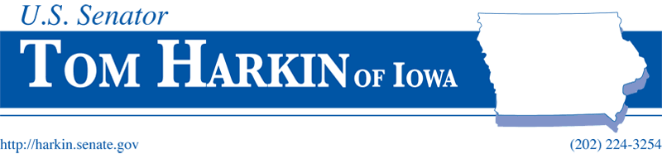

FOR IMMEDIATE RELEASE
December 14, 2009

Contact: Kate Cyrul / Bergen Kenny
202-224-3254

HARKIN: NEW NATIONAL STUDY SHOWS UNHEALTHY FOOD ADVERTISING TO KIDS CONTINUES TO DOMINATE THE AIRWAVES

More than two thirds of advertising used to promote foods of lowest nutritional value

WASHINGTON, D.C. – Senator Tom Harkin (D-IA) issued the following statement on a new, national report out today regarding food marketing to kids. The Impact of Industry Self-Regulation on the Nutritional Quality of Foods Advertised on Television to Children provides the first independent, comprehensive evaluation of the Children’s Food and Beverage Advertising Initiative and its impact on the children’s food marketing environment on television since the major food companies pledged to stop this advertising in 2007.

Harkin chairs the Health, Education, Labor and Pensions Committee and the Senate panel that funds health initiatives. He is also the Senate leader in federal efforts to combat the obesity epidemic by promoting wellness and healthy habits among adults and children.

“Removing the barriers to healthy living has proven results: people select healthier foods, cut down on smoking and exercise more. These small steps reduce chronic conditions and rein in high health costs. But how can we remove these barriers and create a healthier environment when our nation’s kids are barraged with commercials for unhealthy foods every time they turn on the TV?

“The food industry vowed to limit the amount of advertising dollars spent to promote unhealthy foods to children, and focus more on nutritious items. That’s why I am so discouraged by this report out today. When private interests work against the public good, government is obliged to act. We need to examine this issue more closely and figure what needs to be done to achieve balance on the airwaves so that we can improve the health and wellness of our children.”

The complete study is available to the public at www.childrennow.org.

###

